Kilninver Primary School
Autumn Newsletter October 2019

As the leaves start to turn, the nights draw in and woolly jumpers are being looked out, it is the perfect time to reflect on my first term as Acting Head Teacher of Kilninver Primary School.

I cannot thank staff, parents, pupils and the community enough for the warm welcome I have received. Kilninver Primary really is a unique and special community.

It has been an action packed first term and this newsletter gives just a glimpse of the learning, events and skills our pupils have been involved in.

Have a wonderful October break,

Mrs Helen Daniels

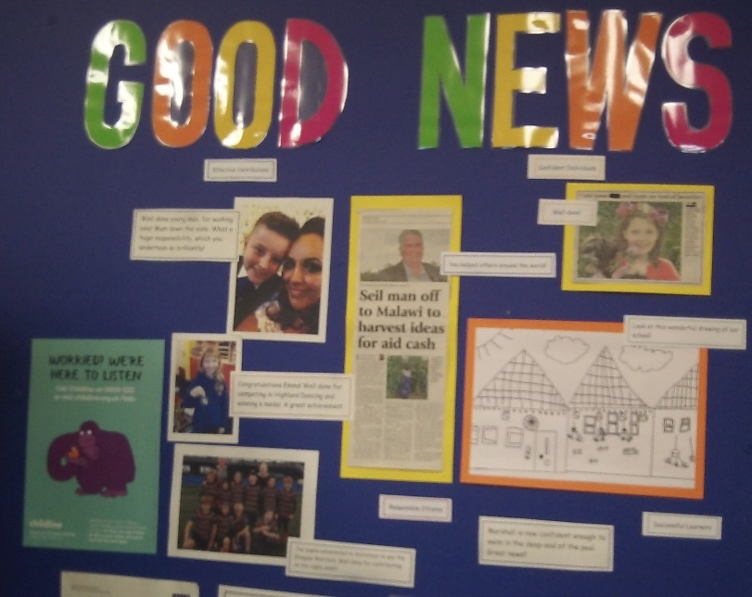
Good News Wall
Our Good News wall is filling up as we recognise and celebrate pupil achievements within and out-with the school.
Pupils have been participating in Highland Dancing competitions, Rugby tournaments and Horticultural Shows.

Please keep the Good News coming in!

Fruit Friday
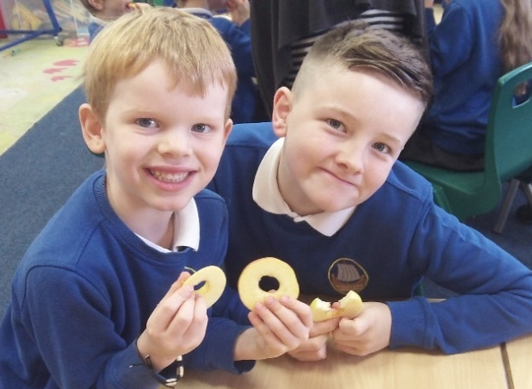
Every Friday morning pupils enjoy freshly prepared fruit and vegetables thanks to our amazing catering manager, May.
Pupils have tried new foods, find enjoyment in sharing healthy options and it is a lovely opportunity to be together as a whole school before our weekly assembly.
“It’s nice because I like to taste different fruits and it’s fun getting together.”

Assembly
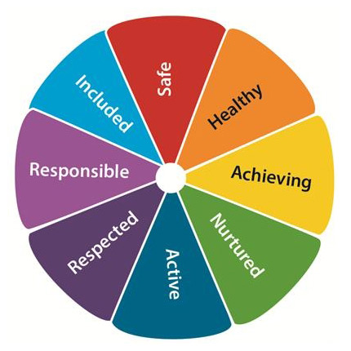
Each Friday morning we come together as a whole school for our weekly Assembly. This term we have been exploring the SHANARRI well-being indicators and what each of them means.
We have also used the opportunity to participate in action songs to keep us active! ‘Dance, Dance, Dance’ by Zumba Fitness has been a favourite.
“I like the Head Teacher awards because everyone gets a compliment.”

PTA Ceilidh
After weeks of practising the ceilidh dances with Mrs Currie, the pupils really shone at the PTA ceilidh, showing a great sense of rhythm and fun!
Pupils kicked off the evening with a brilliant performance of ‘This is Me,’ using BSL. Brave solo performances from Francesca and Emma were real crowd pleasers alongside the visiting talent of Donald on his fiddle.
Our thanks to all who planned, prepared and supported the evening. Nearly £400 was raised! These funds alongside a generous donation from Kames Fish Farming Ltd will provide music lessons for all pupils in Kilninver Primary School.
“The dances were really fun, Strip the Willow was my favourite.”
“We were encouraged to be ourselves and not ignore other people – in case they have important information or ideas to share.”
Active Schools
We are delighted to have Allan Wright as our Active Schools co-ordinator. Pupils in P5-7 have undertaken three weeks of Young Leader training and are now utilising their new skills to support whole school games and sport sessions with all pupils at lunch time.

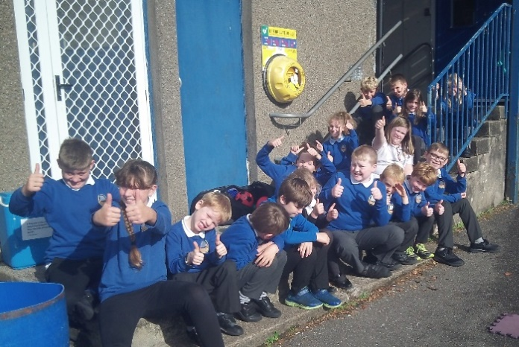
On Monday 30th September, P1-7 participated in the Virtual Games activities; obstacle courses that teams of pupils are challenged to complete as many times as they can in 5 minutes. The sun shone as the pupils encouraged one another, beat personal records and achieved great scores.
Well done team!

Thank you to the Kilninford News, who have made a very generous donation to the school to cover transport costs enabling pupils to attend the Active School events in Oban, later in the year.
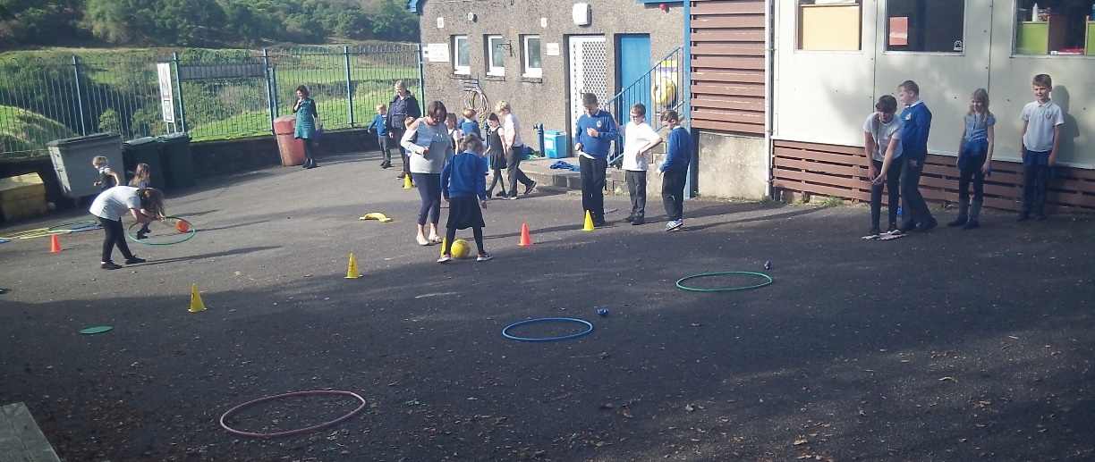
Author Visit
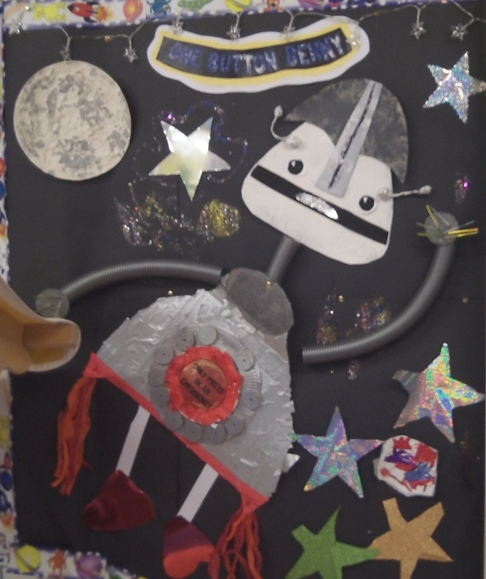
Pupils in the ELC and P1-3 had a wonderful morning when local author, Alan Windram came in to bring ‘One Button Benny’ to life. Pupils wrote a song, danced like a robot, learned about the process of writing a book, guessed super heroes and smiled throughout!
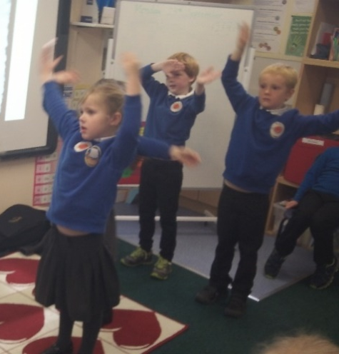

Music
We are delighted to welcome Mr Douglas to Kilninver Primary School. Mr Douglas is facilitating six music sessions with P1-7 between now and Christmas. The pupils are developing musicianship through games and learning how to play the ukulele. It is hoped that pupils will be able to perform two songs by Christmas…so watch this space!

Space
From the ELC through to P7 we have been exploring Space as our IDL this term. P1-4 have explored the solar system, astronaut training, gravity, day and night. Pupils in P5-7 have studied the advancement of space technology. They launched their own rockets and took part in a design task based upon a command module. Their aim - to safely land a hard-boiled egg without it cracking. The results were highly successful!
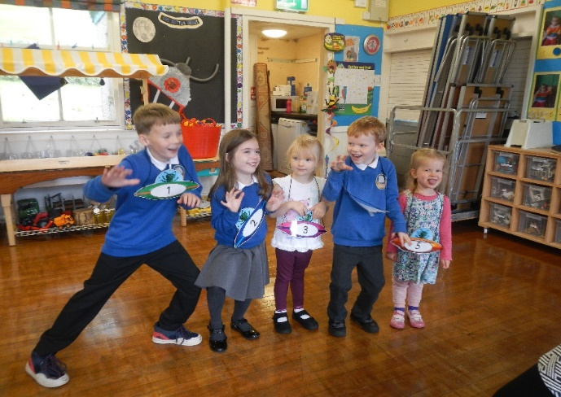
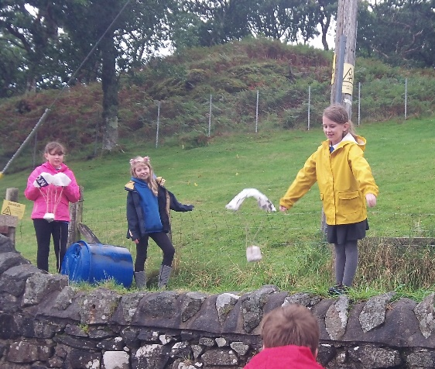

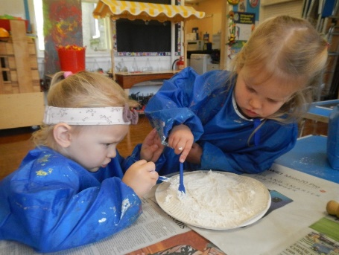
With a little help from Primary 1-4 the ELC enjoyed singing ‘5 Little Men In A Flying Saucer’.

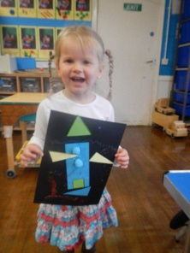
We explored moon textures made from flour and paint. We know the moon is a small ball of rock and its surface has lots of craters, the craters look like big holes!

We have been learning to identity different shapes.
Forest Schools
‘If you go into the woods today, you’re in for a big surprise…’

Being outdoors has been proven to have a positive impact on a person’s well-being. There are also many opportunities for experiential learning to take place and we are very fortunate to have Mr Maddox leading Forest School sessions each week.
In Cuilfail forest there is an amazing shelter that the pupils have made, a well-structured fire pit with surround seating and a fabulous Gruffalo trail complete with hand-crafted animals. If you can, visit the forest over the holidays, there is evidence of learning and enjoyment all around…but look out for the Gruffalo!

Baking
Pupils in P1-4 have had the opportunity to develop skills for life and apply mathematics in context, through baking. They have experienced a great sense of enjoyment and achievement and are keen to try the recipes at home!
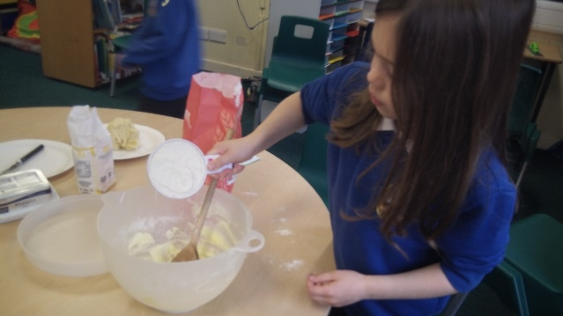
As part of our Harvest Celebration, pupils wrote poems themed around Gratitude.

My Poem of Thanks
By Abi P2

I am grateful for the wonderful world we live in.

Thank you for the sun, stars and moon.

Thank you for the rain, wind and snow.

Thank you for the brightly coloured rainbows.

